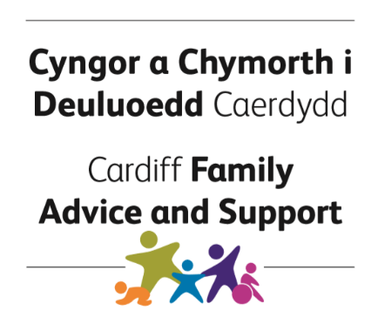

Early Help Referral Form
(For anyone working with families, young people and children)
Cardiff Family Advice and Support (CFAS) is a service for families, young people and children across Cardiff which aims to provide families with the right level of support at the right time.
This form should be filled in to request support from Cardiff Family Advice and Support Services.
This form is also available in Welsh.
Key principles for consent and information sharing
- We are committed to gaining the informed consent of children and/or parents when we wish to share confidential/personal information
- We will respect the wishes of those who do not give consent, except where safety may be at risk or when it is inappropriate to seek their agreement
Have you gained consent from the family to share information and request this support? | ☐ Yes  ☐ No
If the answer is NO, please gain consent from the family to make this request on their behalf and to share their information with us, before proceeding to complete form, unless you have immediate safeguarding concerns.
Are there any immediate safeguarding concerns? |  | Yes ☐ | No ☐
If the answer is YES, stop filling out this referral and instead complete the Multi Agency Referral Form (MARF).
Young person or child details
Name
Address
Postcode
D.O.B | Gender |  |  | Disability Y/N |  | Young Carer Y/N |  | Nationality
Tel No.
Email
Ethnicity of Child/Young Person
Black Caribbean |  |  | Indian |  |  |  | Pakistani
Black African |  |  | Mixed White & Asian |  |  |  | White British
Bangladeshi |  |  | Mixed White & Caribbean |  |  |  | White Irish
Black Other |  |  | Mixed White & African |  |  |  | White Other
Chinese |  |  | Other mixed background |  |  |  | Any other ethnic group
Family Details
Preferred Language of Family
☐ English | ☐ Welsh | ☐ Other (please state)
Please state if the family has any specific requirements (e.g. additional needs, communication requirements, interpreter or signer required, accessibility)

Preferred Method of Contact
☐ Letter | ☐ Email | ☐ Telephone
Please provide any other details that may help us to contact the family

Other family members or significant others in the household
Name | Relationship to child/young person |  | Parental Responsibility |  |  | D.O.B
 |  |  | Yes | No | N/K
Name of siblings | D.O.B | Name of siblings |  | D.O.B
Other Support
Agencies Involved  (e.g. Social Services) | Key Professional Name | Contact Details | Current Involvement

Strengths, Needs and Resources
Each family will have different strengths, needs and resources available to them. Please tell us as much as possible about the family and their situation.
Briefly describe the family’s circumstances
What concerns do you have about the family, young person or child? What could happen if there are no changes?
What is currently working well for the family, young person or child? What are their strengths? What support and resources can they access?
What needs to happen next with the family, young person or child? What are your and the family’s ideas about what happens next to achieve their goals?

Declaration
*Referrer, please read out the following to the Service User*
Cardiff Family Advice and Support collects personal information to help in the provision of services. Some information will be sensitive about matters such as health, disabilities or racial or ethnic background. We may also need to collect information about people that you are working with and those people who are important to you. Your referrer will have told you why we are collecting the information, and explained to you what information about you could or may be shared with others. Respecting your privacy and managing your personal information is a key part of our service.
Some services provided by Cardiff Family Advice and Support are funded by the NHS and by Local Authorities. Some information may also be used to plan future services. This information will be anonymous so you will not be identified. There may be some circumstances where in the public interest, agencies may be required to disclose information that would otherwise be kept confidential.
Services are delivered by teams of professionals. It will be necessary for other members of the team, who may be involved in supporting you, to have access to information about you on a need to know basis. This will include professionals that work for Cardiff Council, Cardiff and the Value University Health Board and other voluntary organisations as appropriate. For future information on how your information is processed in line with Data Protection Law, please refer to the information of data protected provided by Cardiff Council at: https://www.cardiff.gov.uk/ENG/Home/New_Disclaimer/Pages/default.aspx
I understand what information my referrer would like to share about me, who they want to share the information with and why they want to share it.

I have explained to the family, young person or child: | ✔
What personal information we want to share
Why we want to share their information
Who we want to share their information with
That their information will be kept secure
Their right to withdraw or restrict consent
Their right to access their personal information

Name:
Parent/carer
Signature:  Parent/carer |  | Date:

Name:
Young person (if appropriate)
Signature:  Young person (if appropriate) |  | Date:

Name:
Referrer
Signature:  Referrer |  | Date:
Job Title and Agency
Address
Telephone
Email

Please send this referral to:
Cardiff Family Advice and Support
Tel: 03000 133 133
Email: ContactFAS@Cardiff.gov.uk

